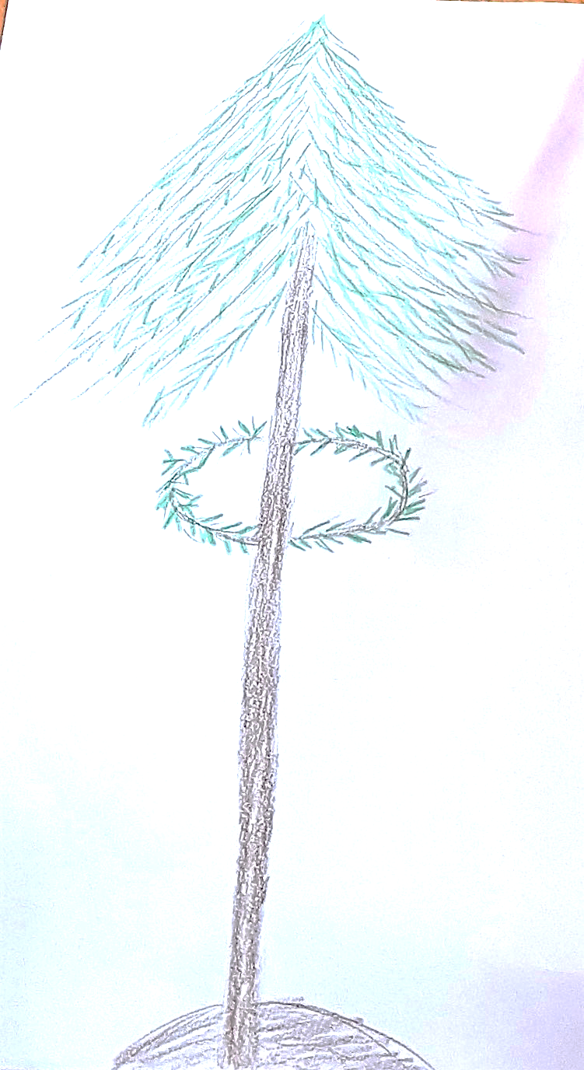
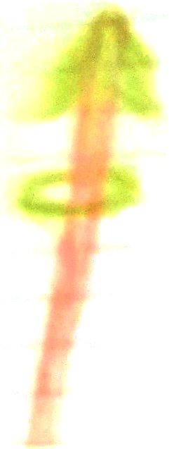
PRVOMAJSKA
BUDNICA
https://www.youtube.com/watch?v=9jYTVlrxCWw
MLAJ

